**Name: Laiba Asif**

**Student Number: R00201303**

**Class Group: COMP1D-Y**

**Lab 8 – K-Maps**

Q1.

1. Before simplifying, what is the Boolean expression for the truth table outlined below?
2. Simplify using K-maps and design a circuit for the simplified expression. Draw the K-map below.
3. Verify its operation using the simulator and paste a snapshot of your circuit below.

**Truth Table:**

|  |  |  |  |
| --- | --- | --- | --- |
| **X** | **Y** | **Z** | **Output** |
| 0 | 0 | 0 | 0 |
| 0 | 0 | 1 | 1 |
| 0 | 1 | 0 | 0 |
| 0 | 1 | 1 | 1 |
| 1 | 0 | 0 | 1 |
| 1 | 0 | 1 | 1 |
| 1 | 1 | 0 | 0 |
| 1 | 1 | 1 | 1 |

**Boolean Expression:**

**Y =** (X’Y’Z) + (X’YZ) + (XY’Z’) + (XY’Z) + (XYZ)

**K-Map:**

|  |  |  |
| --- | --- | --- |
|  | **Z 0** | **1** |
| **XY 00** | **0** | **1** |
| **01** | **0** | **1** |
| **10** | **1** | **1** |
| **11** | **0** | **1** |

E= (XY’) +(Z)

**Circuit:**

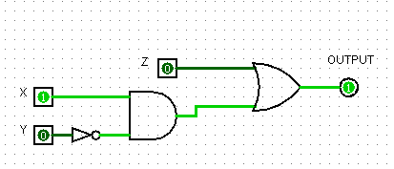

Q2.

1. Design and simplify, using K-maps, a circuit for the following truth table. Draw the K-map below.
2. Verify its operation using the simulator and paste a snapshot of your circuit below.

**Truth Table:**

|  |  |  |  |  |
| --- | --- | --- | --- | --- |
| **A** | **B** | **C** | **D** | **Output** |
| 0 | 0 | 0 | 0 | 0 |
| 0 | 0 | 0 | 1 | 0 |
| 0 | 0 | 1 | 0 | 1 |
| 0 | 0 | 1 | 1 | 1 |
| 0 | 1 | 0 | 0 | 1 |
| 0 | 1 | 0 | 1 | X |
| 0 | 1 | 1 | 0 | 1 |
| 0 | 1 | 1 | 1 | 1 |
| 1 | 0 | 0 | 0 | 0 |
| 1 | 0 | 0 | 1 | 0 |
| 1 | 0 | 1 | 0 | X |
| 1 | 0 | 1 | 1 | 1 |
| 1 | 1 | 0 | 0 | 0 |
| 1 | 1 | 0 | 1 | 1 |
| 1 | 1 | 1 | 0 | 1 |
| 1 | 1 | 1 | 1 | 0 |

**K-Map:**

|  |  |  |  |  |
| --- | --- | --- | --- | --- |
|  | CD 00 | 01 | 11 | 10 |
| AB 00 | 0 | 0 | 1 | 1 |
| 01 | 1 | X | 1 | 1 |
| 11 | 0 | 1 | 0 | 1 |
| 10 | 0 | 0 | 1 | X |

E= (A’B) + (CD’) + (B’C) + (BC’D)

**Circuit:**

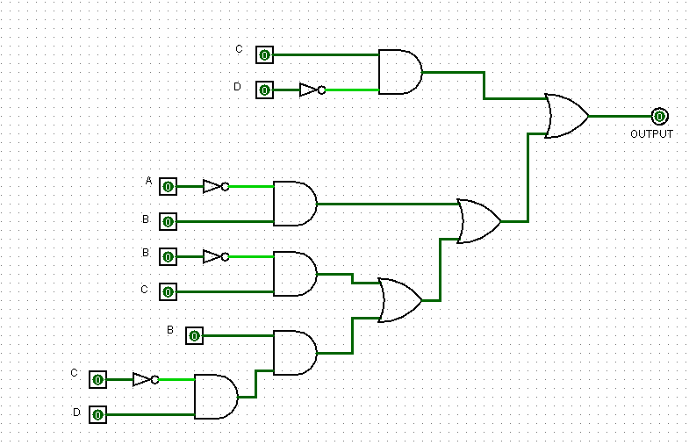

Q3.

1. Design and simplify, using K-maps, a circuit for the following truth table. Draw the K-map below.
2. Verify its operation using the simulator and paste a snapshot of your circuit below.

**Truth Table:**

|  |  |  |  |
| --- | --- | --- | --- |
| **X** | **Y** | **Z** | **Output** |
| 0 | 0 | 0 | 1 |
| 0 | 0 | 1 | X |
| 0 | 1 | 0 | X |
| 0 | 1 | 1 | 0 |
| 1 | 0 | 0 | 1 |
| 1 | 0 | 1 | 0 |
| 1 | 1 | 0 | X |
| 1 | 1 | 1 | 1 |

**K-Map:**

|  |  |  |
| --- | --- | --- |
|  | **Z 0** | **1** |
| **XY 00** | **1** | **X** |
| **01** | **X** | **0** |
| **11** | **X** | **1** |
| **10** | **1** | **0** |

**E= (Z’) + (X.Y)**

**Circuit:**

